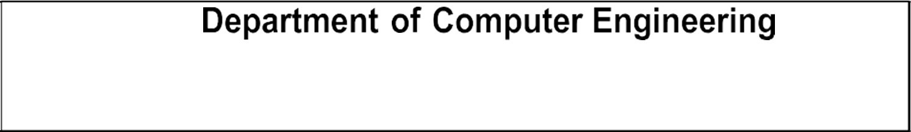

Semester | S.E. Semester IV – CMPN
Division & Batch | Div B Batch 3
Subject | Computer Graphics
Laboratory Teacher: | Divya Nimbalkar
Laboratory | M310A

Student Name | Atharva Sheramkar
Roll Number | 24102B0069
Grade and
Subject Teacher’s
Signature

Experiment Number | 2
Experiment Title | Implementation of Bresenham's line drawing algorithm
Problem  Statement | Draw lines which are of different types like:  Solid  Dashed  Dotted
Resource s /  Apparatus  Required | Hardware: Desktop | Software: Dev C++

Code | #include <graphics.h>  #include <stdio.h>  #include <conio.h>  void bresenham(int x1, int y1, int x2, int y2) { int dx, dy, x = x1, y = y1; int p;  int i=0;  dx = x2 - x1; dy = y2 - y1;  p = 2 * dy - dx;  while (x <= x2) {  if((x % 10) < 5)  {  putpixel(x, y, WHITE);  }  if (p < 0) {  p = p + 2 * dy;  } else { p = p + 2 * dy - 2 * dx; y++;  } x++;  }  }  int main() { int x1, y1, x2, y2;  int gd = DETECT, gm;  printf("Enter the coords of first point (x1 y1): "); scanf("%d %d", &x1, &y1);  printf("Enter the coords of 2nd point (x2 y2): "); scanf("%d %d", &x2, &y2);  initgraph(&gd, &gm, (char*)"");  bresenham(x1, y1, x2, y2);  getch(); closegraph(); return 0;  }
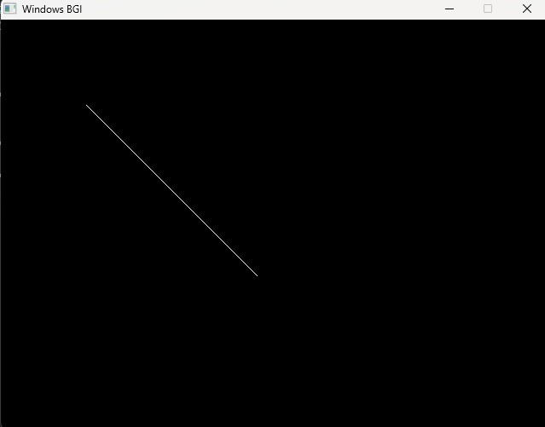

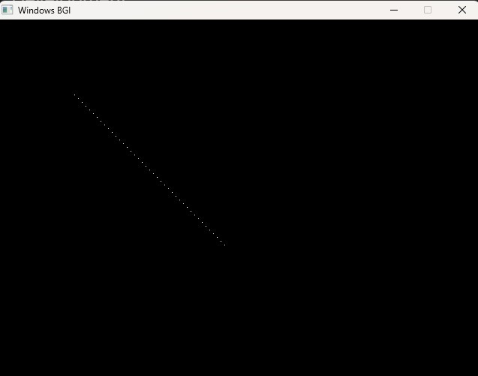

Conclusion | In this experiment, Bresenham’s line drawing algorithm was used to draw a straight line on the screen by plotting pixels one by one. By skipping pixels at regular intervals, dashed and dotted lines were successfully generated from the same algorithm. The output confirms that line alignment follows the screen coordinate system with the origin at the top-left corner, making the algorithm efficient and suitable for basic computer graphics applications.

